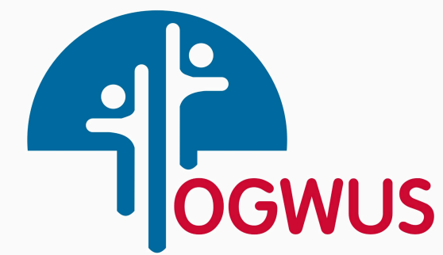

**Ogwus Youth Empowerment and Community Development Organization**

*Empowering the Youth, Building the Future….*

**Youth Empowerment Training Activities - 2025**

* ***Computer & Software development (Microsoft suite, coding, programming, AutoCAD)***
* ***Graphic design – 3D design/printing & Artistic design***
* ***Catering***
* ***Facial Mark-up***
* ***Fashion design***
* ***Hair Dressing & professional haircut***
* ***Technical skill – elect, civil, mechanic, plumbing, Phone repairs etc.***
* ***Arts & music***
* ***Sports – football, physical fitness, virtual gaming etc.***
* *Scholarship Programs*
* *Job placement*
* *Career Counseling*
* *Peer mentorship*
* *Professional registrations*
* *Advocacy*
* *Information dissemination*

Community Development

* *Community Development*
* *Light up Projects*
* *Widow care*
* *Medical outreach*
* *Awareness/Security programme*

Registration is open

*Sport Activities*

*Emergency Response*

*Disaster Management*

*Cultural Programs and Events*

Professional Services