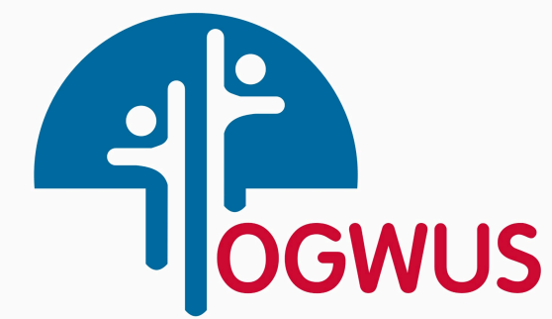

**Ogwus Youth Empowerment and Community Development Organization**

*Empowering the Youth, Building the Future….*

**STATEMENT OF PURPOSE**

**About Us**

We are Ogwus Youth Empowerment and Community Development Organization, dedicated to engaging the youths to develop their skills for meaningful employment, discourage cultism and insecurity, and become active responsible citizens. Founded in 2024, our organization is driven by the passion and commitment to end insecurity and youth agitation in the region, through

* Provision of training to help youths gain employable skills.
* Workshops and programs to develop leadership qualities among young people.
* encouragement of youth participation in community services and social action projects.
* promotion of access to education and health services to improve overall well-being.
* the support of young entrepreneurs with resources and mentorship to start and grow their business
* promotion of Sporting Activities: Organize yearly sports activities and events to promote physical fitness, teach teamwork and encourage international career mobility of young talents.

**Our Mission**

Our mission is to empower young people and foster community development through skill acquisitions and scholarship programs to deserving youths to enable them pursue higher education. We help with developing the youth to have integrity, resilience, leadership, and character for better society. We would organize workshops on various subjects to broaden the knowledge and skills of the youth. Offer tutoring and mentoring services to help youth excel.

Our mission is to encourage youth to participate in community services and volunteer programs to develop a sense of responsibility and civic engagement. Run campaigns on important social issues such as health, environment, and education to raise awareness and inspire action. We will initiate and support projects that address the needs of the community, such as clean-up drives, tree planting, and infrastructure development.

As responsible organization, our mission is to conduct vocational training programs to equip youth with practical skills needed for employment. Encourage and support young entrepreneurs through training, mentorship, and access to resources in the region.

Our mission includes conduct of health education sessions to promote healthy lifestyles and prevent diseases. Provide mental health support services, including counseling and workshops on stress management. Organize yearly sports activities (football, athletics, gaming and events) to promote physical fitness and teamwork.

**Core Values**

At Ogwus Youth Empowerment and Community Development Organization, we are guided by values:

**Integrity:** Maintaining transparency and accountability in all actions.

**Respect:** Valuing the dignity and rights of all individuals.

**Commitment**: Demonstrating dedication to the organization's mission and goals.

**Empowerment:** Enabling individuals and communities to take control of their own futures.

**Equality:** Promoting equal opportunities and non-discrimination.

**Sustainability:** Focusing on long-term positive impacts for communities and the environment.

**Collaboration:** Working in partnership with other organizations, communities, and stakeholders.

**Innovation:** Continuously seeking new and effective ways to achieve objectives. These values form the foundation of our work and inspire us to growth

**Programs and Initiatives**

We have a range of programs aimed at addressing insecurity challenges faced in the Ekpeye nation. Our key initiatives include medical care, skill acquisition, counseling, sports, training, computer coding, programming, software development, AI and environmental sustainability. Through these efforts, the organization aims to invest in the young people to reach their full potential and contribute positively to the development of their communities.

**Community Engagement**

Community involvement is at the heart of what we do. We work closely with the Rivers State Government, Companies operating in the sphere, Ekpeye congress, Upata Tradition Council, HRM & HRHs, stakeholders, community chiefs, and meaningful people, for strong partnership and participation.

In conclusion, Ogwus Youth Empowerment and Community Development Organization is devoted to making a meaningful impact in Youth empowerment and Community improvement. We invite you to join us in this mission and support our efforts to curb insecurity and agitation in the region. Together, we can achieve peace and sustainable development.