***OGWUS YOUTH EMPOWERMENT & COMMUNITY DEVELOPMENT CENTRE***

***AT NDDC ROAD, AHOADA, RIVERS STATE***

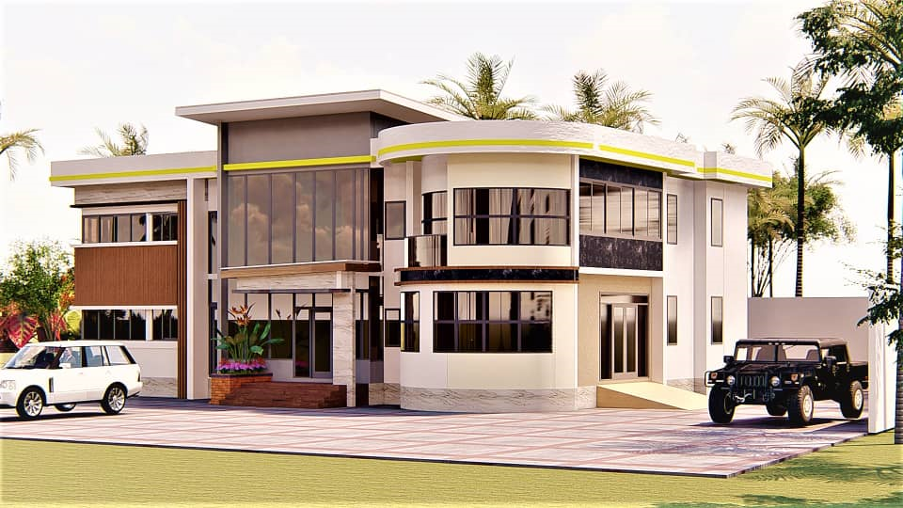 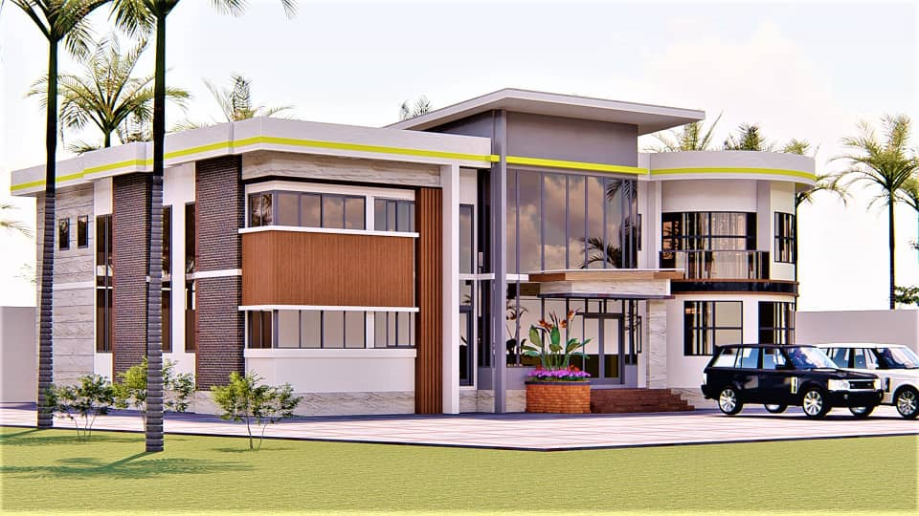

**Funding**

Supporting Ogwus Youth Empowerment and Community Development Organization (OYECDAO) is crucial for several impactful reasons:

* ***Empowering Future Leaders:*** *By funding OYECDAO, you're investing in the next generation of leaders. Our training programs and leadership workshops equip young people with the skills and confidence needed to take on leadership roles in their communities and beyond.*
* ***Reducing Insecurity****: Through our initiatives to deter cultism and insecurity, we help create safer communities. Supporting our organization means contributing to a more secure environment where youths can thrive without fear.*
* *Enhancing Employability: We provide vocational training and skill development programs that prepare youths for meaningful employment. Your support helps reduce unemployment rates and contributes to the economic growth of the region.*
* *Promoting Education and Health: We focus on improving access to education and health services, ensuring that young people have the knowledge and resources they need for overall well-being. Funding OYECDAO means supporting a healthier, better-educated youth population.*
* *Fostering Entrepreneurship: We offer resources and mentorship to young entrepreneurs, helping them start and grow their businesses. Your support nurtures innovation and economic development, creating opportunities for self-sufficiency and prosperity.*
* *Encouraging Active Citizenship: By encouraging youth participation in community services and social action projects, we cultivate responsible, active citizens who are committed to positive change. Supporting our organization means fostering a culture of civic engagement and community improvement.*
* *Promoting Physical Fitness and Teamwork: Our sports activities and events promote physical fitness, teamwork, and international career opportunities for young talents. Funding OYECDAO supports the holistic development of youths, both physically and socially.*
* *By investing in OYECDAO, you are not just supporting an organization; you are contributing to the transformation of lives and communities. Your support helps build a brighter, more secure future for the region, making a lasting impact on the lives of young people and their communities*

Supports

1. Structural work of the Complex
2. Finishing & Furnishing of Complex
3. 2 x Coast Buses
4. 4 x 18 seater Buses
5. 2 x 200kva Generators
6. 400 Desktop computers (CPU, Screen & accessories)
7. 50 Laptop computers
8. 10 x Projectors and digital projector boards
9. 2 X video cameras/4 x cameras
10. 15 x Smart TV ( 65” X 2, 55” X 9)
11. 400 x Conference room seats
12. 15 x Split unit AC
13. 2 x Photocopying Machines

BANK DETAIL

Account Name: **Ogwus Youth Empowerment and Community Development Organization**  
Account No.: **0068068010**  
Bank: Stanbic IBTC

**Naira Account**

Account Name: Ogwus Youth Empowerment and Community Development Organization

Account No.: 0068067910

Bank: Stanbic IBTC

**Dollar Account**

Account Name: Ogwus Youth Empowerment and Community Development Organization

Account No.: 0068067958

Bank: Stanbic IBTC

**Euro Account**